**Name of Experiment:** Process handling in Linux.

**Aim and Objective:**A process is an important topic in Os.so it’s important things to know more about process.in this lab we have learned following things.

* + To know how to create a process using command line.
  + To know how to kill a process using command line.
  + To know how to locate a process using command line.

**Experimental Setup:**

**Creating the process**:

1.Create a simple process in gedit and terminate this process using ctrl+c.

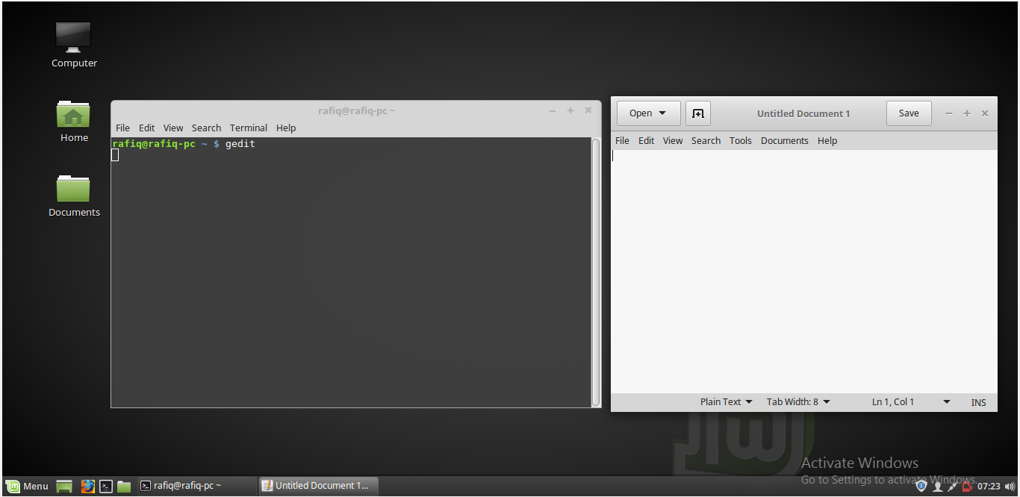

2. Open another process with job number and process id.

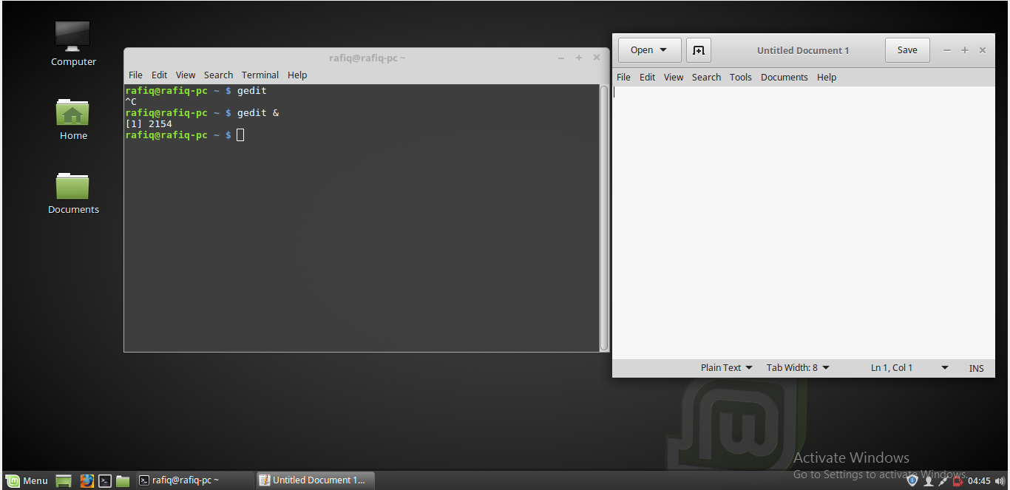

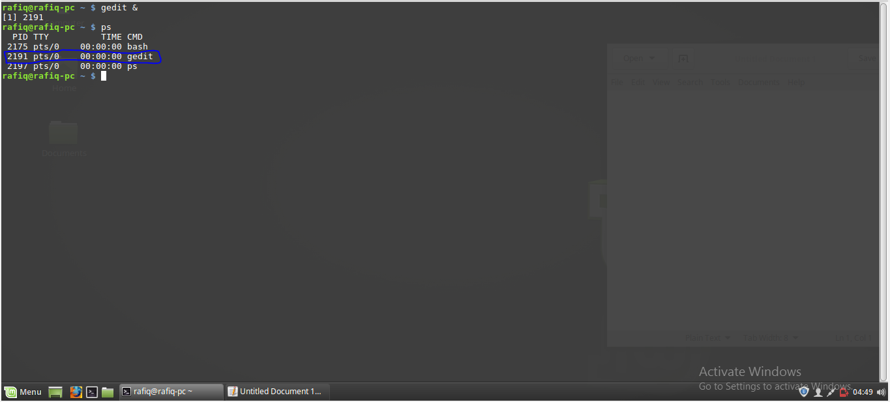

4.**Jobs:**This command show that one job is runnig.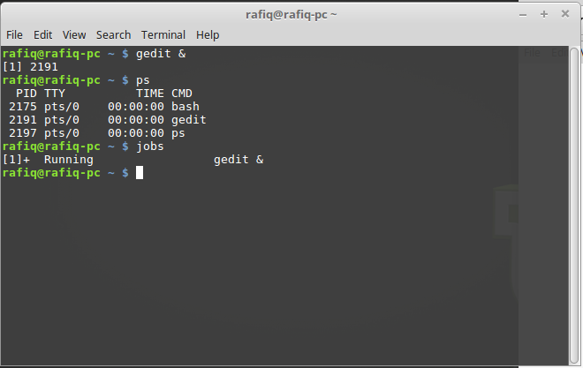

**killing the process:**

**kill PID:** PID is a number referencing the offending process. One should obtain the PID from a command like ps aux. If a process refuses to die, one can alternatively specify kill -9 PID which should terminate the process by any means, even uncleanly or if it will mess up the system.

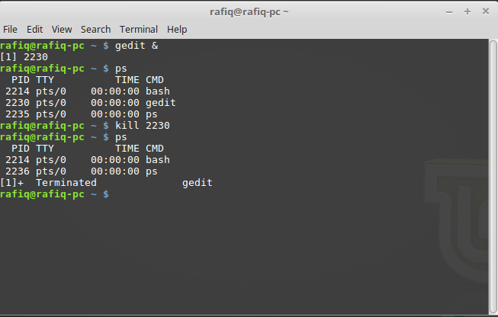

**Killall:**program Killall kills *by name* all instances of said program. If there are for example 4 gedit sessions open, killall gedit will do just that; kill all gedit sessions. kill would simply take the specified PID of the offending gedit process you wish to kill, and kill that one only.

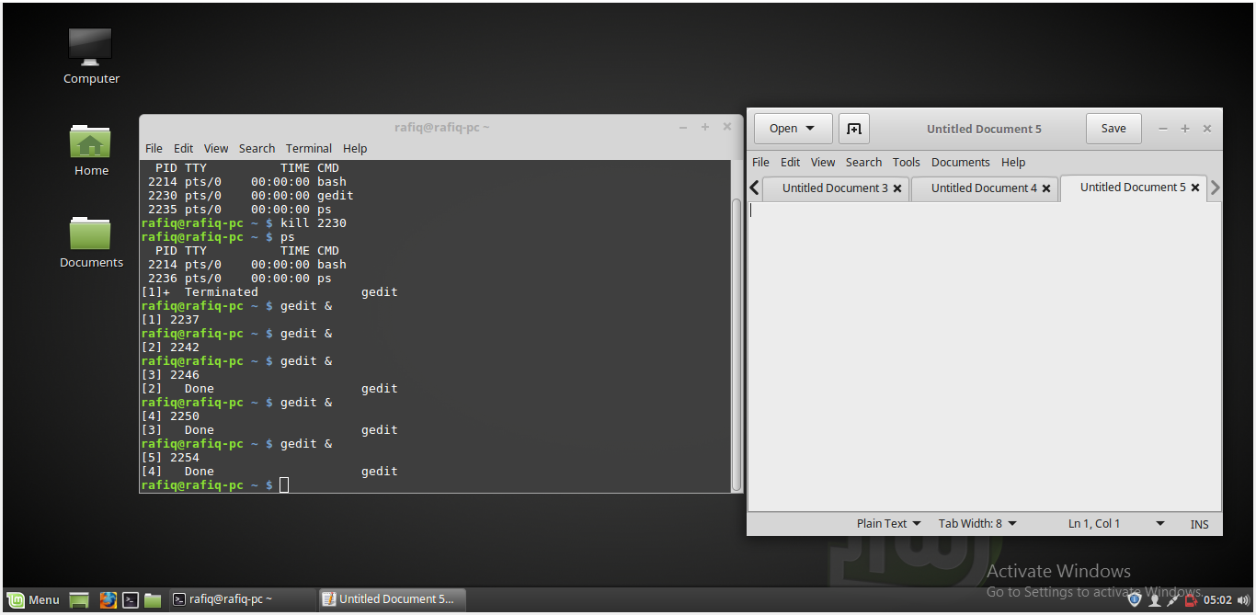

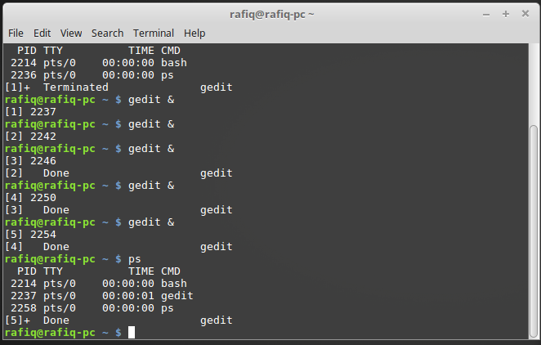

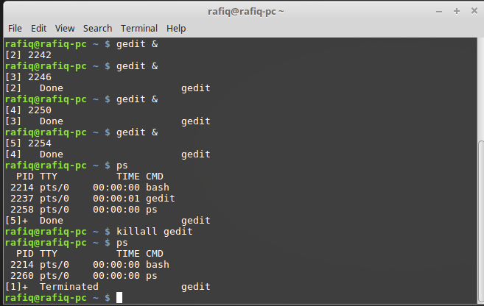

**Locating the process:** The first step in killing the unresponsive process is locating it. There are two commands I use to locate a process: top and ps. **Top** is a tool every administrator should get to know. With top, you get a full listing of currently running process. From the command line, issue to

Locating the process: The first step in killing the unresponsive process is locating it. There are two commands I use to locate a process: top and ps. **Top** is a tool every administrator should get to know. With **top**, you get a full listing of currently running process. From the command line, issue **top** to see a list of your running processes.

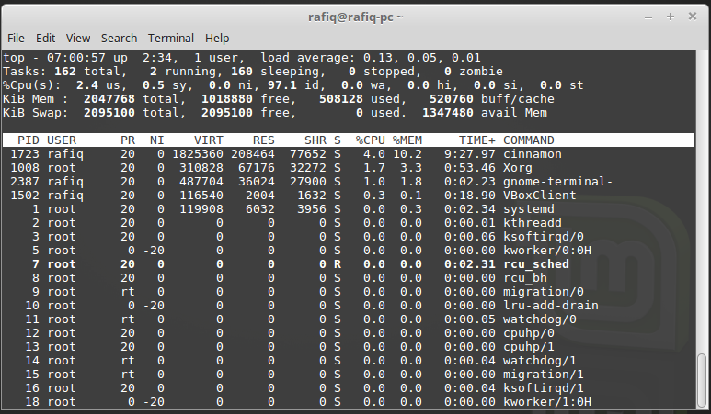

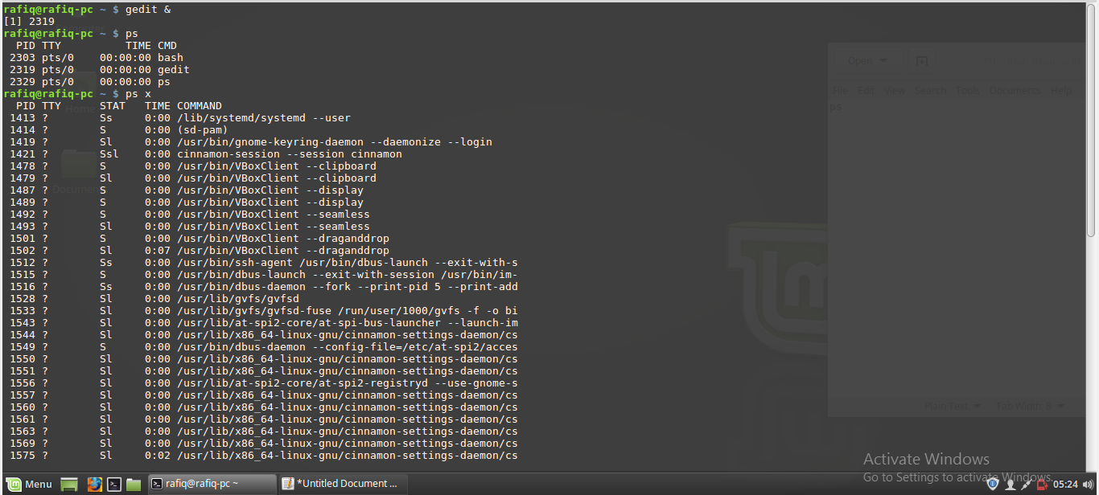

**ps aux:**

The aux options are as follows:

• a = show processes for all users

• u = display the process's user/owner

• x = also show processes not attached to a terminal

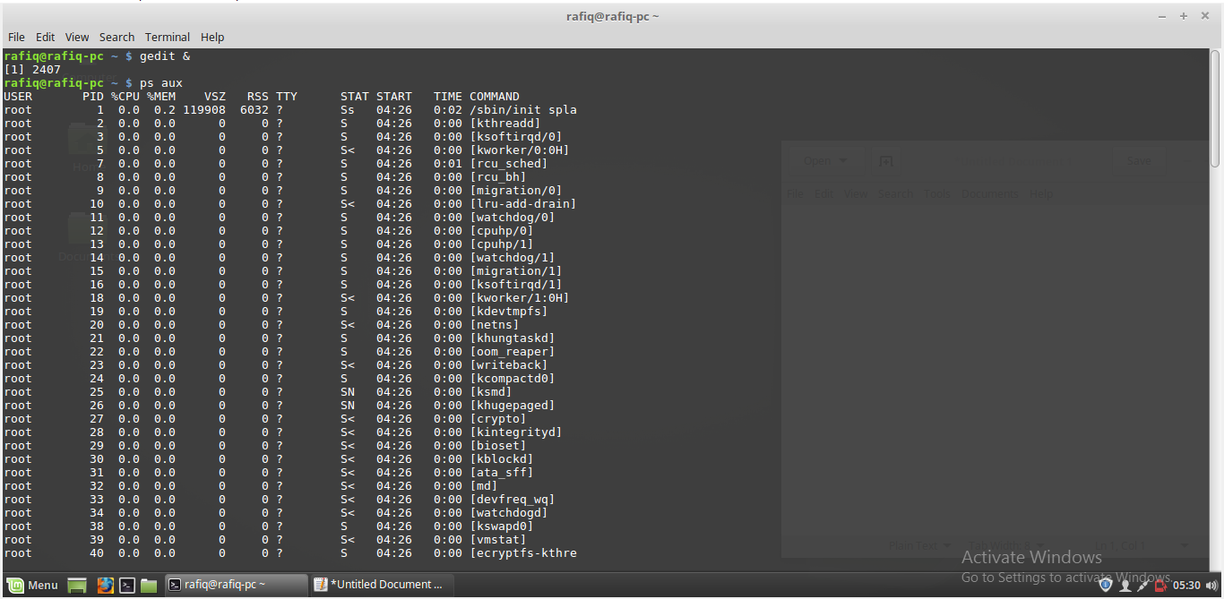

We can’t kill all the processes. some process are not permitted to kill. Such as .

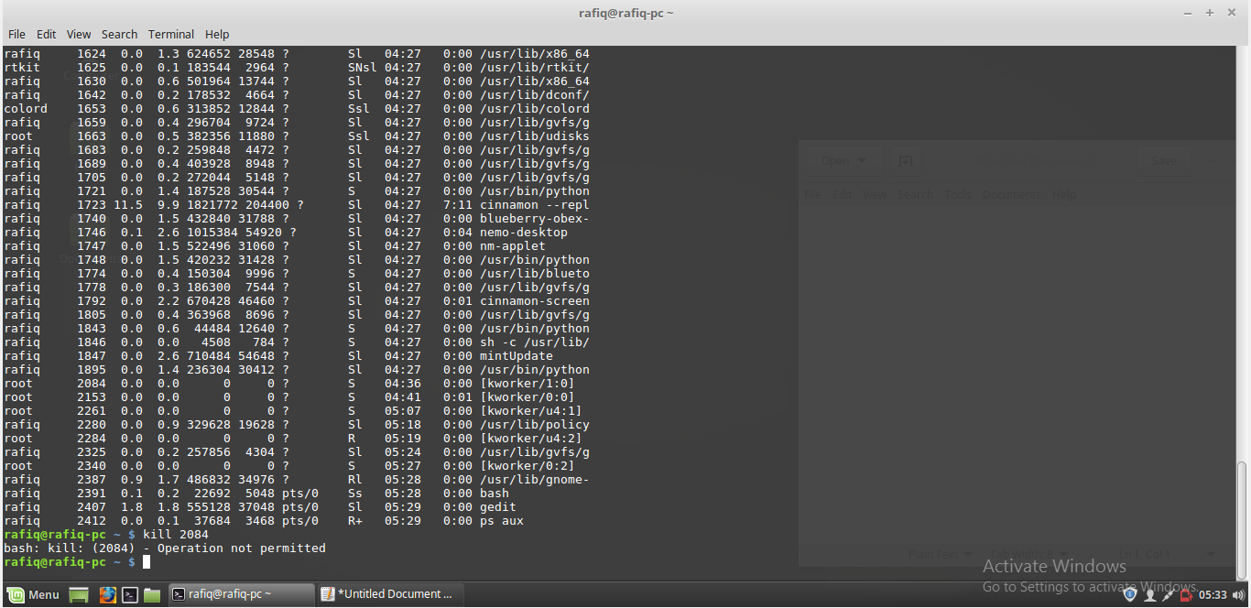

But the processes created by us we can delete this easily. Such as.

Before the delet process gedit.

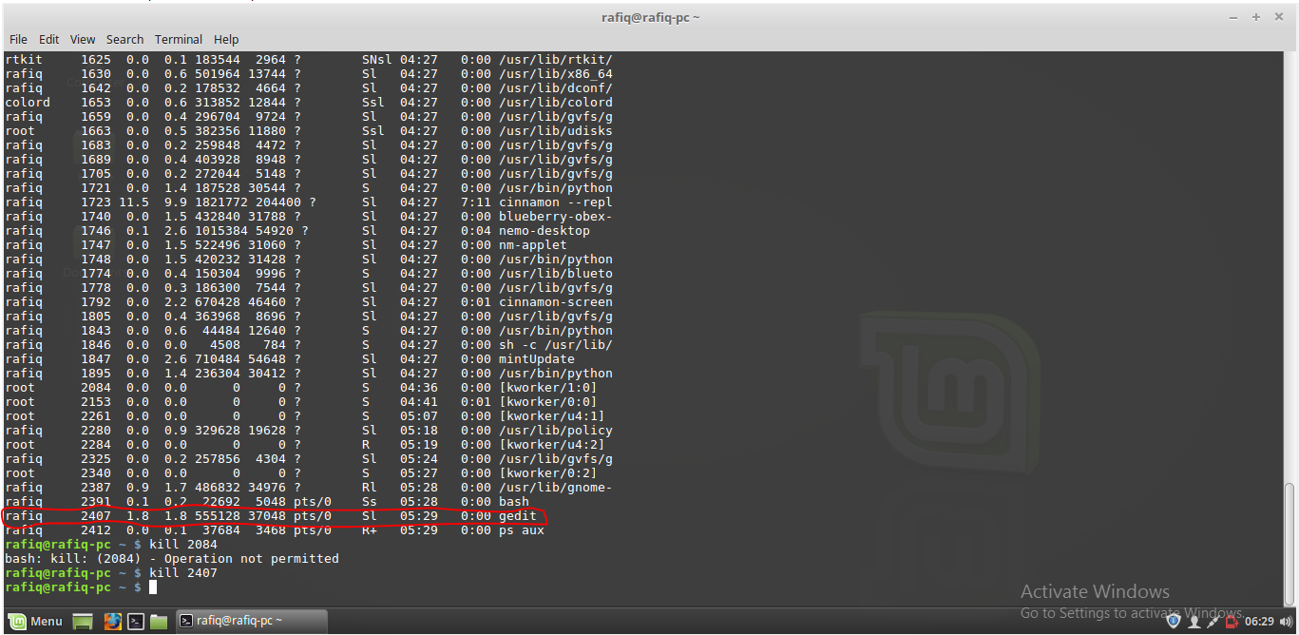

After the delete the process gedit.the red mark line shows the process is terminated.

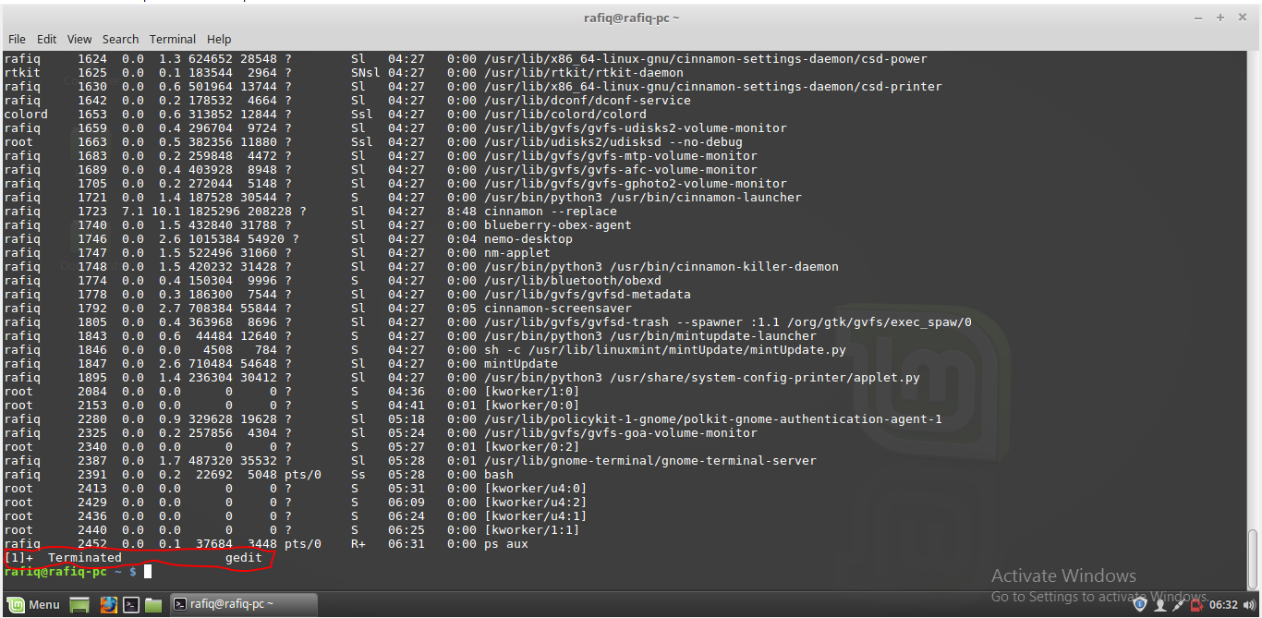

**Conclusion:** A process is the unit of work in most systems. Systems consist of a collection of processes. Operating-system processes execute system code, and user processes execute user code. All these processes may execute concurrently.In this lab we have learned about process.we also learnd opening a process ,killing process and showing of running process in OS .